1. **Agenda**:
   1. How Spring Boot autoconfigure the Kafka Consumer.
2. This info is needed as in the following cases.
   1. If we face any issue while configuring the consumer.
   2. If we want to override some configurations.
3. 
4. KafkaAutoConfiguration.java is invoked at the time of Spring Boot Startup and then it is going to autoconfigure based on the properties we define in the application.yaml class.
5. 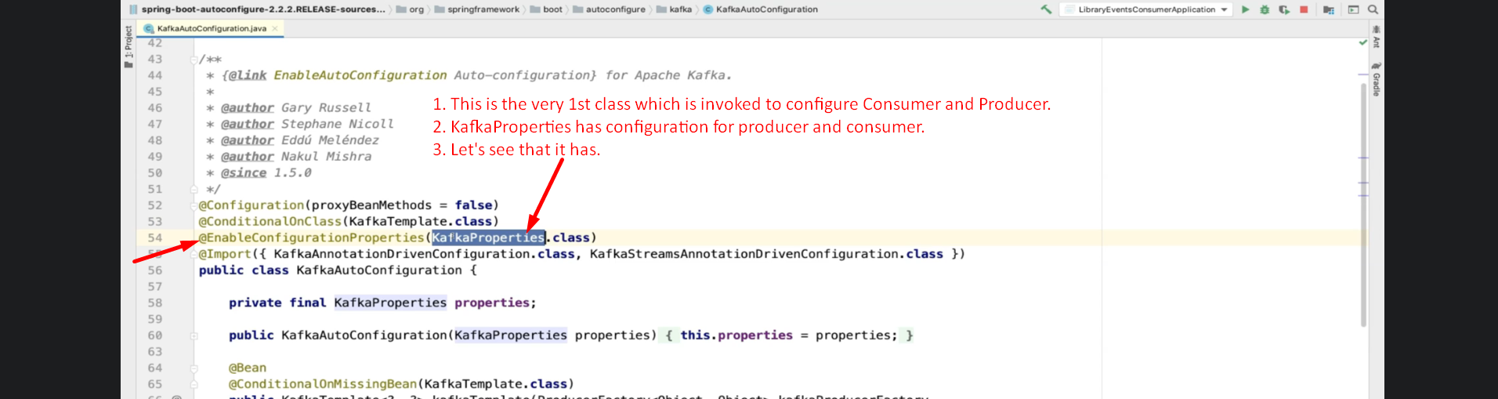
6. It is very involved lecture talking about internal things related to kafka Consumer configuration, creation and many more.